## Deep learning:

* A neural network of more than three layers, including the inputs and the output, can be considered a deep-learning algorithm.
* Deep learning is a sub-field of machine learning dealing with algorithms inspired by the structure and function of the brain called artificial neural networks. In other words, It mirrors the functioning of our brains.

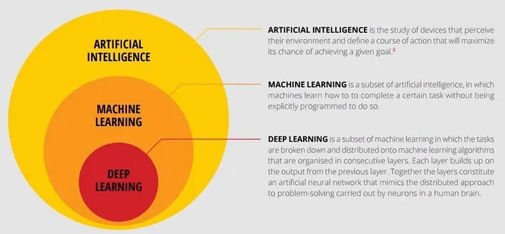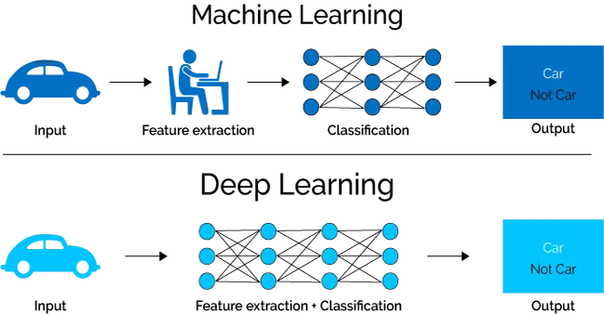

## History of Deep learning:

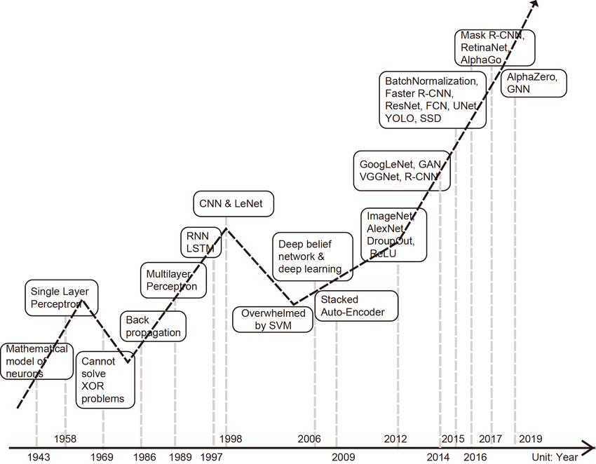

The first ANN was proposed in 1944, but it has become very popular in recent years. Deep learning was introduced in the early 50s but it became popular in recent years due to the increase in AI-oriented applications and the data that is being generated by the companies. While classical machine learning algorithms fell short of analyzing big data, artificial neural networks performed well on big data. The history of deep learning can be traced back to the early days of artificial intelligence (AI). In 1943, Warren McCulloch and Walter Pitts created a mathematical model of neurons in the brain, which was the first artificial neural network.

* In the 1950s, Frank Rosenblatt developed the perceptron, a simple two-layer neural network that could be trained to recognize patterns. However, the perceptron had limitations, and it was not until the 1980s that neural networks began to be used more widely.
* In the 1980s, Geoffrey Hinton and others developed a new type of neural network called the backpropagation algorithm. Backpropagation allowed neural networks to learn more complex patterns, and it led to a renewed interest in neural networks.
* In the 1990s, deep learning research continued, but it was still a relatively niche field. However, in the early 2000s, there were a number of breakthroughs that led to a resurgence of interest in deep learning.
* One of the most important breakthroughs was the development of the convolutional neural network (CNN). CNNs are a type of neural network that is specifically designed for image processing. They have been used to achieve state-of-the-art results in a variety of image recognition tasks, such as face recognition and object detection.
* Another important breakthrough was the development of the recurrent neural network (RNN). RNNs are a type of neural network that is specifically designed for processing sequential data. They have been used to achieve state-of-the-art results in a variety of natural language processing tasks, such as machine translation and speech recognition.
* In the past decade, deep learning has made significant progress in a wide variety of tasks, including image recognition, natural language processing, speech recognition, and machine translation. It is now one of the most active and promising areas of research in AI.